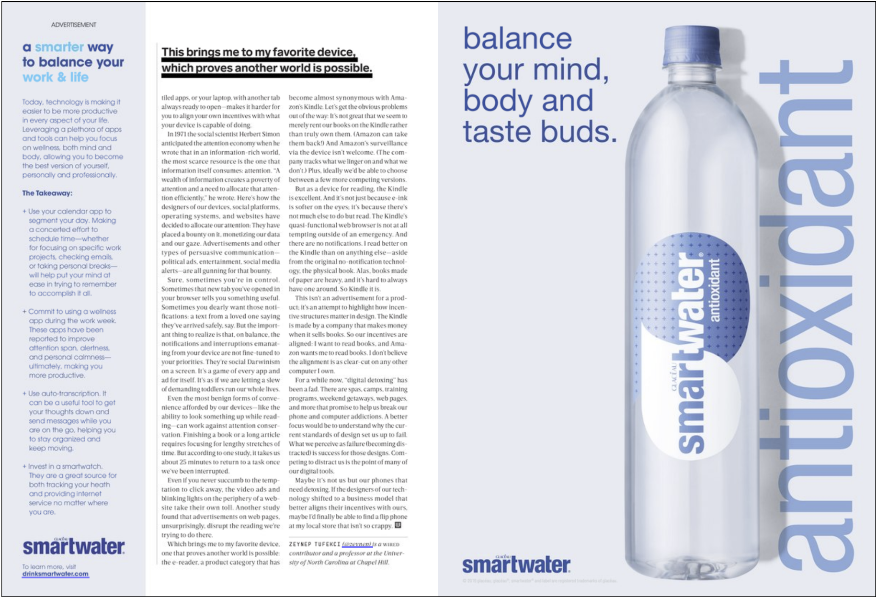

Professor Justin Gautreau

WRI-01-54

2 November 2019

This water is better than regular water because it’s smartwater!

This two-page smartwater ad can be found in WIRED magazine being published on October 1st, 2019 on pages sixteen and seventeen. The magazine’s audience is middle-aged with 65% being men and 35% being women. The ad’s unstated message is to balance life and work with a bottle of smartwater. I think the ad is effective, Smartwater is creating a sense of fear of being unhealthy and that drinking this water will improve your health and balance your life and work. The need to feel safe is prominently seen in the smartwater ad. This is one of fifteen basic appeals talked about in “Advertising’s Fifteen Basic Appeals.” The advertisements are appealing to the audience using one more of these appeals. The ad also hints at elitism, that smartwater is better than other water bottles, being larger and “balancing your taste buds.”

The audience is middle aged men and women and typically they are usually having a difficult time balancing their work, family, and life in general. They could be at their mid-life crisis and would be looking for ways to better balance their life. The middle age reader might be looking for a smarter way to balance their life and would stumble into this article and see the smartwater ad and usually have the money to spend on expensive water.

For this smartwater ad, there are two pages. On the first page there is just text and the far left side column of the page talking about technology and how it is making it easier to be more productive, with the rest of the page talking about attention saying “A wealth of information creates a poverty of attention and need to allocate that attention efficiently,” which I will later explain how this is effective for the smartwater ad. Then, finally we the smartwater ad on the second page. There’s a smartwater bottle in the center with text next to it saying “antioxidant” and text on the top left saying, “balance your mind, body and taste buds.” And lastly on the bottom left is the smartwater logo with the whole ad being light blue a calming color.

The first thing we see and read on the first page is the text on the far-left column, which talks about efficient ways to balance your life with apps and gadgets considering how busy middle age men and women are this could be helpful for them. This is seen before the smartwater ad to start getting the reader to think about ways to balance their life. Smartwater efficiently places the ad in the right place, being after the article. They do this by first getting the reader to think more thoroughly about how they can balance their lives, implanting a desire to be healthier than the reader may not have thought about in the beginning.

Second, we see the smartwater bottle which is the largest object in the ad, taking up most of the page. The light hits the smartwater bottle making it shine and casts a shadow on the wall behind it. This makes the smartwater bottle seem special and gives off a vibe of elitism among other water bottles. Whoever drinks this water is elites because this water is better than other water, with the brand name blatantly being “smartwater”.

The third thing that we see is text antioxidant sideways being about the same height and width as the smartwater bottle, meaning that the water probably has antioxidant which can be found in whole foods. This is another hint at elitism, if you drink smartwater you will be healthier. This is also fulfilling the reader’s desire to be healthier.

Third, is the text on the second page at the top left of the smartwater bottle “balance your mind, body and taste buds.” We assume they are talking about the smartwater being able to balance your mind, body and taste buds because the text is next to the cap of the water bottle making it seem like if you drink a smartwater bottle it will provide you “balance your mind, body and taste buds.”

The fifth is the ad’s logo/brand seen several times throughout the two pages of the magazine implanting the logo subconscious into your mind so when seen in stores or anywhere else the reader would recognize the brand. If the reader needs to balance their life they will remember that smartwater can help with that.

The smartwater ad first makes desires for the reader on the first page that the reader didn’t even have in the first place then the reader is shown the smartwater ad to fulfill their desire. Smartwater is a status symbol being expensive water which represents elitism. The ad makes it seem more superior than other water bottles, sets a fear of being unhealthy. They use text like balance your mind, and body to get the reader to fix their unbalance and messes lives with smartwater.

When I first saw the smartwater ad I was shocked to see water that could balance your mind, body and taste buds. It was just water. Water, in general, is good for you and is what humans drink daily. That is the reason why I found interest in this ad. I wanted to see how smartwater was different from regular tap water or filtered water. Or at least why people would buy smartwater over other alternatives.